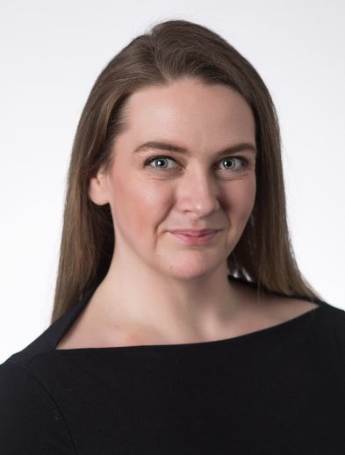
Liz Callahan
Director of External Affairs
and Special Projects
Based in EWI’s New York office, Liz Callahan’s work focuses on EWI’s Buffalo Manufacturing Works advanced manufacturing center. Liz is responsible for supporting the executive team on external relations. She also oversees special projects and initatives, creating structure for new and ambiguous ideas and partnerships. This includes the Shift 2.0 program. Funded in partnership with the EDA and New York State, Shift 2.0 helps small and medium-sized manufacturers operate efficiently, compete effectively, and grow. Liz develops EWI partnerships in New York State and with federal partners.

BACKGROUND & PROJECT EXPERIENCE
Prior to joining EWI at Buffalo Manufacturing Works, Liz was Workforce Development Manager at the Buffalo Niagara Partnership. While there, she worked closely with businesses of all sizes and gained extensive experience in bringing cross-sector partners together to address critical manufacturing needs across the Western New York region.

EDUCATION & AFFILIATIONS
B.A. Purchase College, State University of New York

AWARDS
Women in Manufacturing, Buffalo Business First
Brenda McDuffie Award of Excellence, Buffalo Urban League Young
Professionals
Women Who Move the City, Big Brothers Big Sisters of Erie County

